Why Microfiction?

- Please sit by your reader, read the text, and discuss the necessities for microfiction.

For the reader:

Microfiction’s appeal to the modern reader is not surprising when considering the average adult’s attention span isn’t much longer than the time it takes to click a mouse or tap a touch screen, right?
Don’t write bad microfiction. It’s far too easy to make a whole lot of it and the world will crumble under the weight of it all.
It’s possible this is true, but more than convenience, a reader likes a good story. Good stories come in all shapes and sizes—all lengths and forms. If a novel can be thought of as a ten course meal, and a short story as an excellent deli-sandwich. A microfiction piece might be an exquisite chocolate truffle. All are food. All are enjoyable. But they’re each very different. Microfiction is a scrumptious, bite-sized nugget of a story. It packs big flavor and satisfaction into a small package.

For the writer:
As a writer, microfiction forces you to really look at your prose and determine what’s essential and what isn’t; what’s redundant and what isn’t. Honing these skills on microfiction can make your short story and novel-length prose that much sharper, but it’s also an art form of its own—a different medium for expression—as different from shorts stories as short stories are from novels. It’s fun to explore different story-telling media, and some writers find that microfiction is their medium of choice.

Tips for Writing Microfiction:
The real key to microfiction is efficiency of text. You don’t need to tell less of a story, and you don’t need to summarize the story. You need to make careful word and phrase choices that are able to paint vivid pictures and imply more than their brevity would suggest. “Show, don’t tell” most certainly still applies. Beyond that, consider all the features that tend to make any story good—characterization, plot, conflict, setting and atmosphere—if you want a reader to engage with the piece, there should be a hook, and some sense that something important happens. This is no small feat to perform in so few words, but it can be done. Cick here for an excellent example of Lydia Davis’s process. https://litreactor.com/columns/the-art-of-microfiction

Lydia Davis’s Very Short Stories
Lydia Davis, who was awarded the Man Booker International Prize in 2013, has been publishing short stories utterly unlike anyone else’s for almost 40 years. Sometimes as brief as a sentence or several paragraphs, they dispense with conventional narrative and character in favor of astringent wit and aphoristic insight. Davis’s commentary on these two drafts of an early story reveals that every word is ripe for scrutiny.
- Lydia Davis
- July/August 2014 Issue

In those days (fall of 1973, age 26, living in the country in France), I would force myself to stay at the desk for a certain number of hours, giving myself admonitions (written in my notebook) like “Alright, let’s establish one firm rule: from when I get up—at 7 or 7:30—until, say, 12:30 … allowing one break for a modest, circumscribed, abrupt meal of porridge or eggs at about 10:30, nothing else will be allowable—no cooking, no cleaning, no walking, no talking or playing, etc.”
At the desk, I would write and write, in my notebook, whatever came to mind, as a way of working up to the point of writing something like a story. This would not be free-association writing—I never did that—but thoughts, descriptions of what was around me, always written carefully, revised. I might write something incomplete, possibly the beginning of a story, but possibly just a fragment:
Although the house seemed very bright, clean, and elegant, one could tell by the number of flies that swarmed in it, landed on the furniture, and crept up and down the windowpanes, that something about the house was rotten.
(This arose from observing the many flies that did indeed walk up and down the windowpanes in front of my desk. Often, I immediately fictionalized something real in my own situation, as practice, or as a way of starting on a story. In those days, I said that flies “crept,” whereas now, after reading Nabokov on flies, I would never say that—they do not creep, but walk.)
“In a House Besieged” grew directly out of my situation and the descriptions I wrote in the notebook. Just before starting the first draft of this story, I noted the “shots of hunters this morning (as I lay in bed still trying to order my thoughts),” followed by a lull. “And everything is silent and peaceful until there is another muffled shot.”

First Draft
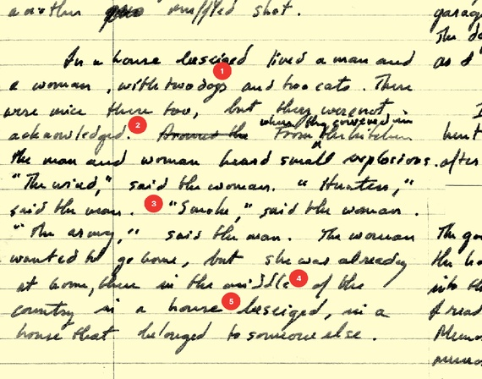
1. The two dogs and two cats, as well as the mice, were part of my real situation, but I probably felt that they lessened the ominousness of the story, and certainly that the lack of “acknowledgement” of the mice was chatty and distracting. 2. The addition of “where they cowered in” adds explicit drama. Kitchen has comfortable associations (until one has to cower in it). 3. The change from smoke to rain replaces something inaudible with something audible. 4. Ending the story on the phrase in a house besieged is stronger than the rather anticlimactic and irrelevant in a house that belonged to someone else, which is confusing, adding new information, and beside the point. 5. By the time of the final version, I knew how to spell besieged.

Final Draft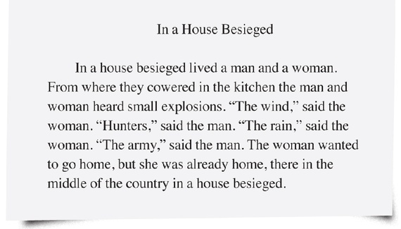

2. Visit the website below and look for process choices:

Every Day Fiction
bite-sized stories for a busy world

http://everydayfiction.com/
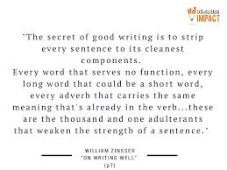

- Pick two lines to rework: Typle them on this handout and work with your partner to rewrite/condense/minimize the language
- Next, choose one thing you could eliminate
- Be able to show process of change in your writing---must be visible
- check out this website and peruse http://nationalflashfictionday.co.uk/links.html

